Siddhi Vinayak Secondary School
Butwal-15, Mainapur, Rupandehi
First Terminal Examination- 2083
Class: 10 F.M= 75
Time: 3 hours Subject- C.Maths P.M= 30
Students are required to answer in their own words as far as practicable.
Credit shall be given to clarity and originality, not rote knowledge.
Attempt all the questions:
1. In a survey conducted among 250 student studying in class 10 of a secondary school for the purpose of conducting online classes, it was found that 130 students have laptop, 150 students have both the devices.
a. If the set of total students is U then, write the cardinality of U. (1)
b. Present the above information in a Venn-diagram. (1)
c. Find the number of students who do not have both the equipment. (3)
d. What is the difference between the number of students who have only only equipment and those who do not have any? (1)
2. Ram barrowed RS 60000 from Shiva for 2 years at the rate of 10% p.a simple interest. At the same rate he invested the same sum for the same time at the compound interest compounded annually.
a. Define compound interest and S.I. (1) b. Find the Compound interest received by ram after 2 years. (2)
c. What is the reminding amount with Ram after paying principal and compound interest to Shiva ? find it. (2)
3. A photocopy machine is purchased for RS 80000. After for 2 years, only RS 30000 is earned. The price of machine depreciates annually at the rate of 20% and the machine is sold after 2years.
a. The initial price of machine is RS V_{o} , annual rate of compound depreciation is R% and the price of machine after T years is RS V_{T}, express V_{T} in terms of V_{O}, R% and T. (1)
b. Find the selling price of the machine after 2 years. (1) c. Find the total profit or loss in percentage on selling the machine. (2)
4. Brother Ram, who is in Nepal, went to the bank with some Nepalese rupees to send the 5000 US Dollars needed for his Sister Sita who is studying in America. After 6 months his sister sent 5000 dollars to brother from America At that time Nepali currency was devaluated by 10% Brother Ram went to the bank again to exchange the dollar to Nepali rupees .(1US dollar = NRS.130)
a. How much NPR was deposited in the bank by Ram to send 5000 US dollar to his sister in the beginning? (1)
b. How much Nepalese rupees of $5000 will be received after 6 month. (2)
c. How much profit or Loss did the brother Ram get in the whole transaction? find it. (1)
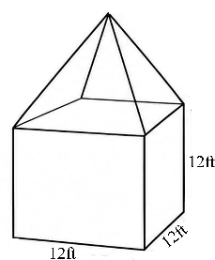
5. The given solid object is made by cube and a square base pyramid. the length of each edge of the cube is 12ft and the overall height of the solid is 20ft.

a. Write the formula for finding volume of the square base pyramid. (1)
b. Find the slant height of pyramid. (1)
c. Is RS 3500 sufficient for coloring in the roof of the pyramid when the the cost per square feet is RS 15? write with reason . (2)
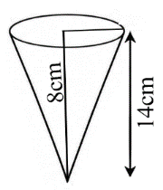
6. Given solid object is formed by combining a hemisphere and a cone. The vertical height of cone is 8cm and total height of solid is 14cm.

a. What it the radius of the base(r) of the cone? Find it. (1) b. What is the volume of the combined solid? Find it. (2) c. Is RS 150 sufficient to colour the surface of hemisphere part of the solid at the rate of 50 paisa per square cm? (1)
7. The radius of base of the given cylinder tank is 70 cm. Its Cylinder tank is 70 cm. Its Capacity is 3000 liter.
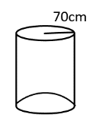
a. Find the height of the cylinder. (2)

b. In the water tank, there is 2156 liter of water. How high is the water in the tank? (2) c. Find the Total surface area of the given tank. (1)
8. The amount deposited by Hari in a cooperative in 10 days is given
below. He deposits the amount for one month in this sequence.
RS 500, RS 700, RsS900, RS 1100, RS 1300, RS 1500, RS 1700, RS 1900, RS 2100, RS 2300.
a. Which sequence is formed by the deposited amount? (1)
b. How much amount does he deposit in one month? (2)
c. Which amount is more than by how much between the amount deposit in 20 days and the amount deposited in remaining 10 days? Compare it. (2)
9. The sum of present ages of two brothers is 78 and the product of the ages after two years is 1680.
a. Write two conditions by assuming the age of elder brother by X and younger brother by Y in mathematical sentence. (1)
b. Find the present ages of elder brother and younger brother. (3)
c. After how many years the ratio of their ages will be $\frac{25}{26}$ (1)
10a. Simplify: $\frac{a}{(a-b)(a-c)}$ + $\frac{b}{(b-a)(b-c)}$ + $\frac{c}{(c-b)(c-a)}$
b. Solve: 9^{x} + $\frac{1}{9x}$ = 9$\frac{1}{9}$ . (3)
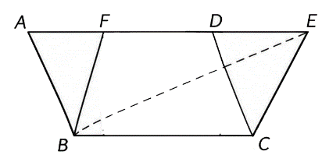
11. In the figure, Parallelogram ABCD and BCEF and ∆EBC are standing on the same base BC and between the same parallel lines BC and AE.

a. write the formula to find area of parallelogram. (1)
b. prove that the area of parallelograms standing on the same
base and lying between same parallel lines are equal in area. (2)
c. If the length of base of parallel-gram ABCD is 12cm and height is
10cm, find the area of ∆EBC. (2)
12. a. Simplify: $\frac{x+y}{x-y}$ - $\frac{x-y}{x+y}$ (1)
b. Solve: 4^{x}+ $\frac{1}{4x}$ = 16$\frac{1}{16}$ (3)
13: Himani planned to have two children at an interval of 4 years after married.
a. what is the probability scale of any event E? Write it. (1)
b. Find the probability of having both children are daughter. (1)
c. Show the probability of possible outcomes of getting son and daughter in a tree diagram. (1)
d. Find the probability of having at least one daughter. (1)
14. A boy 1.5m high is flying a kite. The stretched string of length
150 $\sqrt{2}$m has made an angle of 45° with the horizon then:
a. write the value of cos 45°. (1)
b. Draw the figure according to given information (1)
c. What is the height of kite from the ground? Find it. (1)
d. Find the angle made by the string with horizon of the kite is at the height of 107.56m from the ground. (1)
15. The monthly expenditure of some families is given below:
Expenditure amount (in RS thousand) | 10-20 | 20-30 | 30-40 | 40-50 | 50-60
No. of family | 3 | 2 | 5 | 6 | 4
a. What does L represent in the formula of finding median?
(Md) = L+$\frac{i}{f}$ ($\frac{N}{2}-cf$) of a continuous series? (1)
b. Find the mean ($\overline{X}$). (1)
c. By what percentage the mean ($\overline{X}$) is less than the median (Md)? Find it by calculation. (2)
d. How many maximum number of families are there who expense less than median expenditure? Find it. (1)
16. There are 10 red and 9 white balls of the same shape and size in a bag. Two balls are drawn randomly one after another without replacement. a. write the multiplication law of probability. (1) b. Find the probability of getting both red balls. (1) c. Show the probability of all the possible outcomes in a tree Diagram. (2)
d. Calculate the ratio of probability of getting both balls are same colour to the different colour. (1)

'The End'.

